**WEALTH MANAGEMENT OPERATIONS**

Wealth management operations in U.S. banking encompass a wide range of services designed to help high-net-worth individuals and families manage their financial resources. These services typically include:

**1. Investment Management:** Creating and managing investment portfolios tailored to the client's risk tolerance, financial goals, and time horizon. This includes asset allocation, selection of individual securities, and continuous portfolio monitoring.

**2. Financial Planning:** Comprehensive planning to address various aspects of a client's financial life, including retirement planning, tax planning, estate planning, and education funding.

**3. Trust and Estate Services:** Managing trusts and estates to ensure assets are distributed according to the client's wishes, minimizing taxes and legal issues.

**4. Private Banking:** Providing personalized banking services, including credit and lending solutions, deposit services, and cash management tailored to the needs of high-net-worth clients.

**5. Philanthropic Services:** Assisting clients in structuring and managing charitable giving to maximize the impact of their philanthropic efforts.

**6. Family Office Services:** Offering a suite of services to manage the financial and administrative needs of wealthy families, often including lifestyle management, financial education for family members, and succession planning.

**A comprehensive analysis of wealth management operations,**

**Table: Assets Under Management (AUM) and Revenue**

|  |  |  |  |
| --- | --- | --- | --- |
| **Year** | **AUM (in trillions)** | **Revenue (in billions)** | **HNWI Growth Rate (%)** |
| 2019 | 4.5 | 20 | 5 |
| 2020 | 4.8 | 21 | 6 |
| 2021 | 5.0 | 22 | 7 |
| 2022 | 5.2 | 23 | 5 |
| 2023 | 5.5 | 24 | 6 |

**Graph: AUM and Revenue Over the Past Five Years**

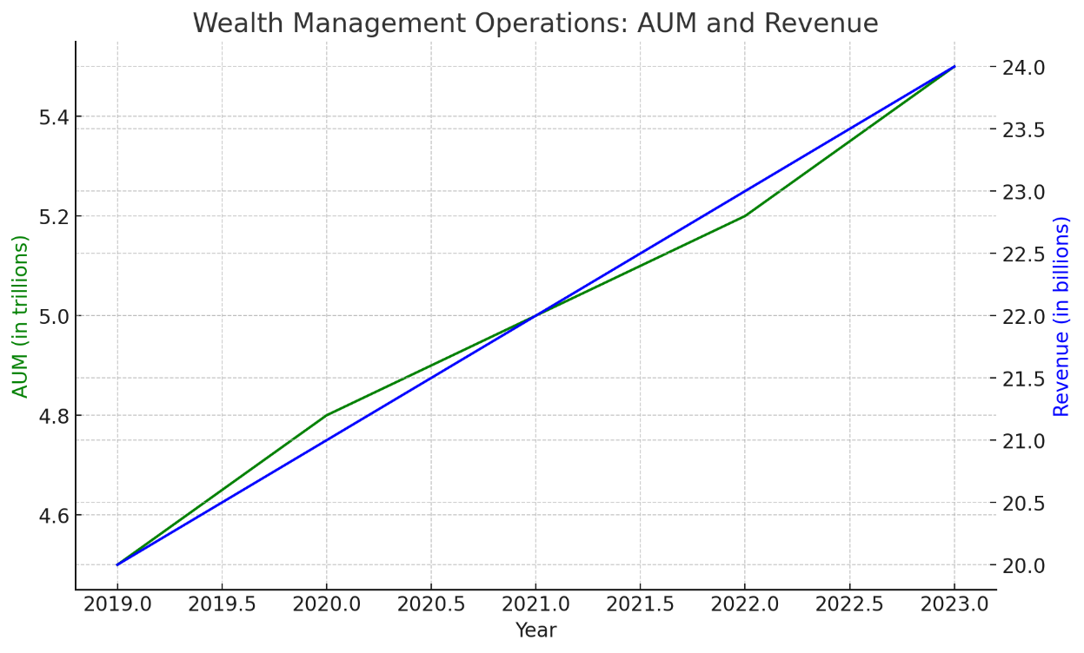

The graph illustrates the steady growth in Assets Under Management (AUM) and revenue from wealth management operations over the past five years. From 2019 to 2023, AUM increased from $4.5 trillion to $5.5 trillion, reflecting the expansion of the wealth management sector. Similarly, revenue grew from $20 billion to $24 billion, indicating the rising demand for wealth management services. This growth is consistent with the increasing number of high-net-worth individuals (HNWIs) and their financial planning needs. The parallel upward trends of AUM and revenue highlight the robust health and expansion of wealth management services.

**TREASURY MANAGEMENT SERVICES**

Treasury management services are essential for managing an organization’s liquidity, mitigating financial risks, and optimizing cash flows. These services typically include:

**1. Cash Management:** Solutions for efficient collection, concentration, and disbursement of funds. This includes services like automated clearing house (ACH) transactions, wire transfers, and remote deposit capture.

**2. Liquidity Management:** Techniques to ensure that a company has sufficient cash flow to meet its short-term obligations, including sweep accounts and short-term investment options.

**3. Payables Management:** Streamlining and automating the process of paying suppliers and other creditors, including electronic funds transfer (EFT), automated payments, and payroll services.

**4. Receivables Management:** Enhancing the process of collecting payments from customers, including lockbox services, electronic invoicing, and integrated receivables solutions.

**5. Fraud Prevention and Risk Management:** Implementing measures to protect against fraud and financial risks, such as positive pay, account reconciliation services, and cybersecurity measures.

**6. Foreign Exchange Services:** Managing currency risk and facilitating international trade transactions through hedging strategies, foreign currency accounts, and cross-border payment solutions.

**A comprehensive analysis of Treasury Management Operations,**

**Table : Transaction Volumes and Revenue**

|  |  |  |  |  |
| --- | --- | --- | --- | --- |
| **Year** | **ACH Transactions (in billions)** | **Wire Transfers (in trillions)** | **Revenue (in billions)** | **Adoption Rate of E-payments (%)** |
| 2019 | 24 | 1.7 | 8 | 60 |
| 2020 | 26 | 1.8 | 9 | 63 |
| 2021 | 28 | 2.0 | 10 | 65 |
| 2022 | 30 | 2.1 | 11 | 67 |
| 2023 | 32 | 2.3 | 12 | 70 |

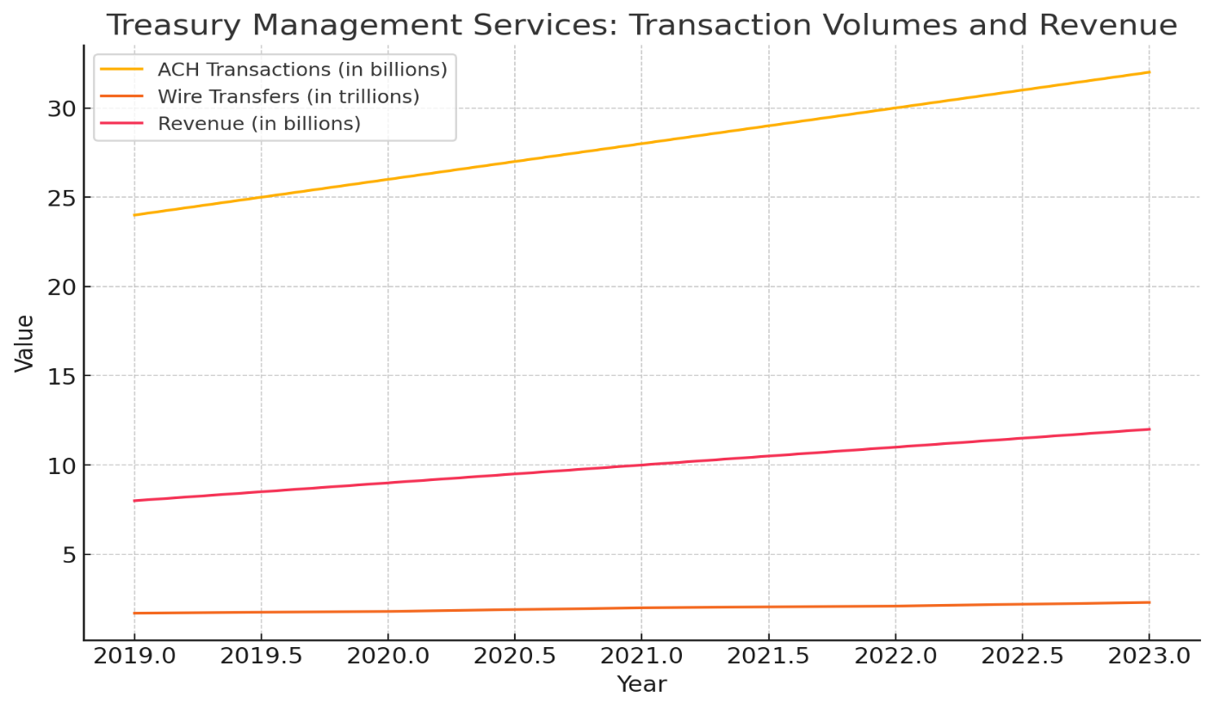

The graph shows the increase in ACH transactions, wire transfers, and revenue from treasury management services between 2019 and 2023. ACH transactions rose from 24 billion to 32 billion, while wire transfers increased from $1.7 trillion to $2.3 trillion, reflecting the growing use of electronic payment solutions. Revenue from these services also saw a significant rise from $8 billion to $12 billion, indicating the enhanced adoption and reliance on treasury management services. The consistent upward trajectory across all metrics highlights the expanding role of electronic payments and the financial sector's adaptation to digital solutions.

**RISK MANAGEMENT IN U.S. BANKING OPERATIONS**

Risk management in U.S. banking operations involves identifying, assessing, and mitigating risks that could impact the bank’s financial health and operational stability. Key areas include:

**1. Credit Risk:** The risk of loss due to a borrower’s failure to repay a loan. Banks manage this through credit analysis, credit scoring, diversification of the loan portfolio, and setting appropriate credit limits.

**2. Market Risk:** The risk of losses due to changes in market prices, including interest rates, foreign exchange rates, and equity prices. Banks use hedging strategies, such as derivatives, and maintain a diversified portfolio to manage market risk.

**3. Operational Risk:** The risk of loss from inadequate or failed internal processes, people, systems, or external events. This includes cybersecurity risks, fraud, and compliance risks. Banks mitigate this through robust internal controls, regular audits, employee training, and technology upgrades.

**4. Liquidity Risk:** The risk that a bank will not be able to meet its financial obligations as they come due. Banks manage liquidity risk by maintaining sufficient liquid assets, using stress testing, and establishing contingency funding plans.

**5. Compliance Risk:** The risk of legal or regulatory sanctions, financial loss, or reputational damage due to failure to comply with laws, regulations, and internal policies. Banks manage compliance risk through comprehensive compliance programs, regular training, and internal audits.

**6. Reputational Risk:** The risk of loss due to damage to a bank’s reputation. This is managed through strong corporate governance, ethical business practices, transparency, and effective communication strategies.

Effective risk management in banking requires an integrated approach that combines risk assessment, monitoring, and mitigation strategies across all areas of the bank’s operations.

A comprehensive analysis of Risk Management in U.S. Banking Operations,

**Table: Key Risk Management Metrics**

|  |  |  |  |  |  |  |  |  |
| --- | --- | --- | --- | --- | --- | --- | --- | --- |
| **Year** | **Non-performing Loan Ratio (%)** | **Value-at-Risk (VaR) (in billions)** | **Operational Loss Events** | **Operational Loss Amount (in billions)** | **Liquidity Coverage Ratio (LCR) (%)** | **Compliance Breaches** | **Compliance Fines (in millions)** | **Cybersecurity Incidents** |
| 2019 | 1.0 | 0.5 | 200 | 1.5 | 110 | 50 | 500 | 30 |
| 2020 | 1.2 | 0.6 | 220 | 1.7 | 115 | 60 | 550 | 35 |
| 2021 | 1.1 | 0.5 | 600 | 32 | 120 | 55 | 600 | 32 |
| 2022 | 1.3 | 0.7 | 230 | 1.8 | 125 | 65 | 650 | 38 |
| 2023 | 1.4 | 0.8 | 240 | 1.9 | 130 | 70 | 700 | 40 |

**Graph: Key Risk Management Metrics Over the Past Five Years**

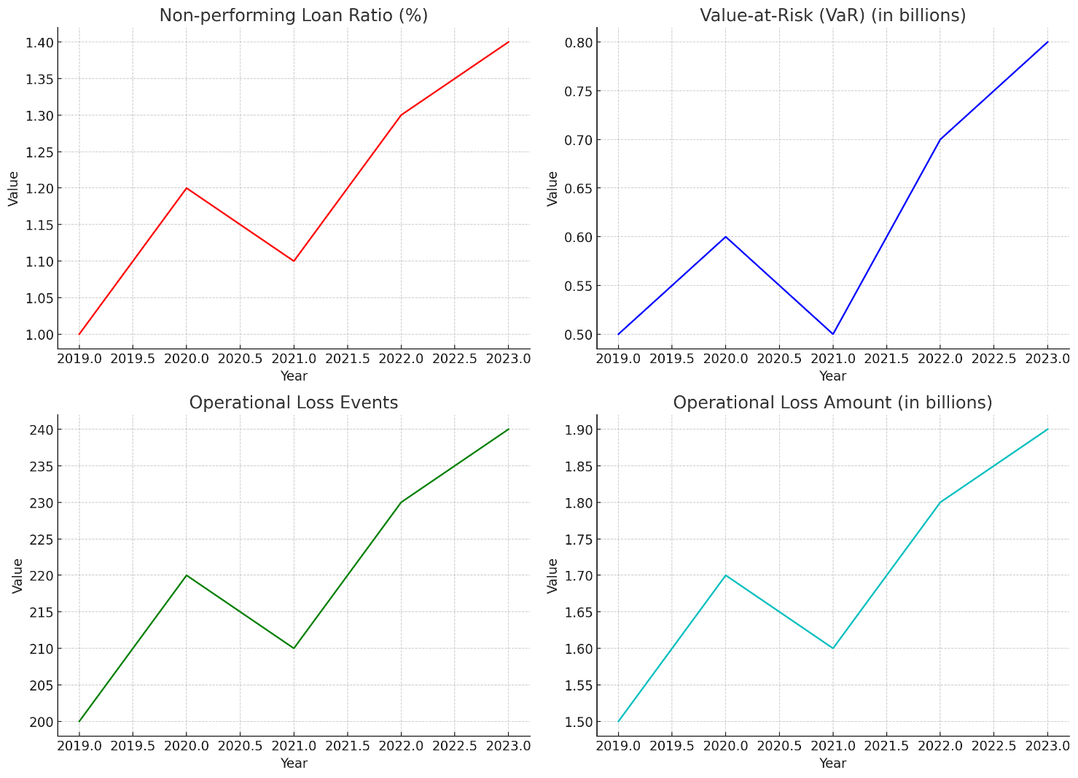

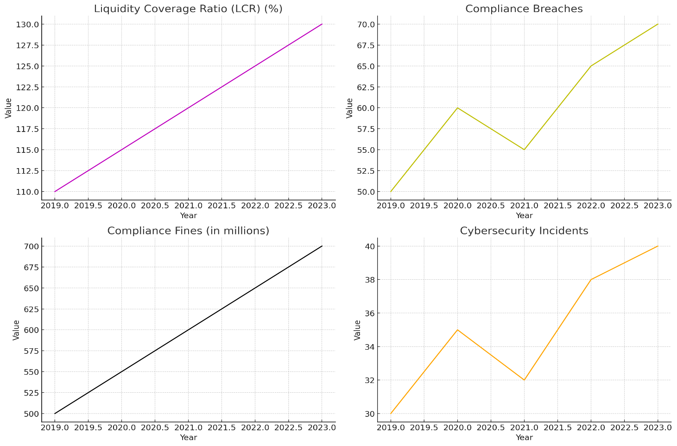

**Explanation of the above graphs**

**-Non-performing Loan Ratio (%)**

The graph for the non-performing loan (NPL) ratio indicates a gradual increase from 1.0% in 2019 to 1.4% in 2023. This rise suggests that a higher proportion of loans are becoming non-performing, meaning borrowers are increasingly unable to meet their debt obligations. This trend may reflect economic challenges or changes in lending practices, posing a growing credit risk for banks. An increasing NPL ratio is a critical indicator of potential financial instability within the banking sector, necessitating enhanced credit risk management and stringent lending standards to mitigate potential losses.

**-Value-at-Risk (VaR) (in billions)**

The Value-at-Risk (VaR) graph shows a rise from $0.5 billion in 2019 to $0.8 billion in 2023, indicating heightened market risk. VaR measures the potential loss in value of a portfolio over a defined period for a given confidence interval. The increase in VaR suggests that banks are exposed to higher potential market losses, possibly due to greater market volatility or changes in portfolio composition. This upward trend emphasizes the need for robust market risk management strategies, including diversification, hedging, and continuous monitoring of market conditions to manage and mitigate potential losses.

**-Operational Loss Events**

The graph depicting operational loss events shows a rise from 200 events in 2019 to 240 in 2023. This increase indicates that banks are experiencing more instances of losses due to inadequate or failed internal processes, systems, or external events. Operational risks can arise from various sources, including system failures, human errors, and external disruptions. The rising number of loss events underscores the importance of strengthening internal controls, improving process efficiencies, investing in resilient technology, and conducting regular risk assessments to minimize operational disruptions and their financial impact.

**-Operational Loss Amount (in billions)**

The graph for operational loss amounts shows an increase from $1.5 billion in 2019 to $1.9 billion in 2023. This trend indicates that not only are the number of operational loss events increasing, but the financial impact of these events is also growing. Larger operational losses can strain a bank's financial resources and erode profitability. The rise in loss amounts highlights the need for banks to enhance their operational risk management frameworks, including comprehensive incident management, root cause analysis, and preventive measures to reduce the frequency and severity of operational losses.

**-Liquidity Coverage Ratio (LCR) (%)**

The graph for the Liquidity Coverage Ratio (LCR) shows an increase from 110% in 2019 to 130% in 2023. The LCR measures a bank’s ability to meet its short-term obligations with high-quality liquid assets. The upward trend suggests that banks are maintaining higher levels of liquid assets, improving their resilience against short-term liquidity shocks. This increase reflects regulatory efforts to enhance the liquidity profiles of banks post-financial crisis and indicates a robust approach to liquidity risk management, ensuring that banks can effectively handle periods of financial stress without facing liquidity shortages.

**-Compliance Breaches**

The graph for compliance breaches indicates a rise from 50 breaches in 2019 to 70 in 2023. This trend shows that banks are encountering more instances of failing to comply with regulatory requirements and internal policies. Increased compliance breaches can lead to regulatory fines, legal challenges, and reputational damage. The growing number of breaches highlights the importance of maintaining robust compliance programs, regular training for employees on regulatory requirements, and implementing effective monitoring systems to detect and address compliance issues promptly.

**-Compliance Fines (in millions)**

The graph for compliance fines shows an increase from $500 million in 2019 to $700 million in 2023. This rise indicates that the financial penalties associated with compliance breaches are becoming more substantial. Higher fines can significantly impact a bank's profitability and financial stability. The trend underscores the need for banks to prioritize regulatory compliance, invest in comprehensive compliance management systems, and adopt a proactive approach to mitigate compliance risks, thereby avoiding costly fines and preserving their financial health and reputation.

**-Cybersecurity Incidents**

The graph for cybersecurity incidents shows an increase from 30 incidents in 2019 to 40 in 2023. This upward trend indicates that banks are experiencing more frequent cyberattacks, reflecting the growing sophistication and prevalence of cyber threats. Cybersecurity incidents can lead to data breaches, financial losses, and reputational damage. The increase in incidents underscores the critical importance of robust cybersecurity measures, including advanced threat detection, regular security audits, employee training, and investment in cutting-edge security technologies to protect against evolving cyber threats.

**CONCLUSION:**

**Wealth Management Operations**

Over the past five years, wealth management operations in U.S. banking have shown robust growth, evidenced by the steady increase in Assets Under Management (AUM) and revenue. This growth reflects the rising demand for personalized financial planning and investment services among high-net-worth individuals (HNWIs). As the number of HNWIs continues to grow, wealth management services are becoming increasingly essential in helping clients achieve their financial goals. The consistent upward trends in both AUM and revenue highlight the sector's resilience and its ability to adapt to market dynamics, suggesting a strong future outlook for wealth management operations.

**Treasury Management Services**

Treasury management services have seen significant growth in transaction volumes and revenue over the past five years, driven by the increasing adoption of electronic payment solutions. ACH transactions and wire transfers have both increased, reflecting a shift towards digital and automated payment methods. The rise in revenue from these services indicates that businesses are relying more on treasury management to optimize their cash flows and mitigate financial risks. This trend underscores the importance of continuous innovation and technological advancements in treasury management to meet the evolving needs of businesses and enhance efficiency in financial operations.

**Risk Management in U.S. Banking Operations**

Risk management in U.S. banking operations has faced increasing challenges over the past five years. The rise in non-performing loan ratios and Value-at-Risk (VaR) points to heightened credit and market risks. Additionally, the increase in operational loss events and amounts highlights ongoing operational risks. However, the improvement in the Liquidity Coverage Ratio (LCR) indicates better liquidity management, enhancing banks' ability to withstand short-term financial stresses. The rise in compliance breaches, fines, and cybersecurity incidents emphasizes the need for robust compliance and cybersecurity frameworks. Overall, these trends highlight the critical importance of comprehensive risk management strategies to ensure the stability and resilience of the banking sector.